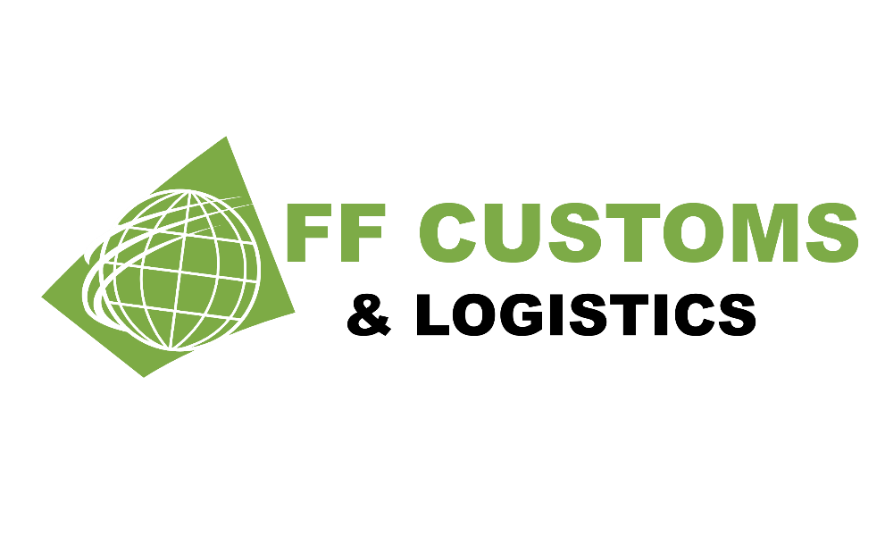

Welcome Pack

Welcome Letter
Thank you for using FF Customs & Logistics LTD.
FF Customs & Logistics is a specialist custom clearance agent in the UK. We handle all UK Customs and border formalities for importers and exporters.
For the convenience of our clients, we offer remote service. We accept document scans electronically, so the driver does not have to come to our office.
All information is stored in accordance with GDPR and our software provider, we appreciate and respect the environment and are a paperless company.

We offer a wide variety of service, which include, but are not limited to:

- CDS MRN Clearances
- GMR submission
- Export and T1 documentation

Please visit our website: www.ffcl.co.uk for further details.

We have secured our status with the accreditation of being an Authorised Economic Operator (AEO), which was introduced in order to secure international supply chains. AEO is based on, and compatible with, the World Customs Organisation’s SAFE Framework of Standards which is being implemented by Customs authorities worldwide. This accreditation is an internationally recognised quality mark indicating that our role in your international supply chain is secure, and that our customs controls and procedures are efficient and compliant

We would be grateful if you could complete and return the attached forms as soon as possible:

➔ NC1: Direct Representation Authorisation -Ideally on your Company headed paper
➔ NC2: Company Information Form
➔ NC3: Standing Customs Clearance Instructions (Unless you prefer to send specific instructions for each shipment)

We look forward to working with you

Direct Representation Authorisation

Authorisation
To: -
H.M, Revenue and Customs

From: -
Your full address

Date: -

Dear Sirs,
We (Your Full Company Name and Address), whos’ EORI number is GB (your EORI Number)

And VAT Number is (GB Your VAT Number), hereby authorise and empower FF Customs & Logistics LTD to

act as our “Customs Representative” in a Direct Capacity for the completion and submission of our Import

and/or Export declarations.

We have selected to use Postponed Vat Accounting (PVA) for Clearance off all shipments into the UK

YES (please complete page 4) NO (VAT Must be paid on all shipments upfront)

If you selecting Yes to PVA and if you are not entitled you may be liable to financial penalties by HMRC.

Note: in accordance with the union Customs code, a direct representative acts in the name of the and on behalf of another person. In relation to import/export will be liable for any customs debt arising from the declaration.

Signed:

Position:

Dated:

Notes: (i) Name of the person signing, who must have authority to sign on behalf of the importer or exporter.(ii) Legal name & EORI trader identification no. of the importer or exporter.

Your Company Details

Full Trading Name:

Trading Address:

Post Code:

Main Contact Name:

Main Contact Position:

Office Telephone Number:

Email Address:

Website URL:

Company Registration Number:

Date Company Established:

VAT/EORI Number:

Any Sanctions logged against your Organisation: YES/NO
if YES please specify

Accounts Contact email:

Please complete & return

Agreement and
Authorisation for use PVA Account

Authorisation
To: -
H.M, Revenue and Customs

From: -
Your full address

Date: -

Dear Sirs,
We

hereby authorise and empower FF Customs & Logistics LTD to use our PVA account (GB your VAT number)

I confirm that I have authority to sign documents on behalf of the company.

Yours faithfully

(Your signature)

Your Full Name

Your status within the company

Please complete & return

Customs Clearance Instructions
Please complete the below instructions and be true and correct with your information you provide in order to proceed with your customs clearance via FF Customs and Logistics LTD,

Please advise this needs to be completed per shipment if the consignment details differ to the below e.g. value of the goods to commercial invoice or commodity code, however if not and you regularly import the same goods these can be retained on record and used as standardise instructions from yourselves with future shipments:

EXPORTER/SELLER
IMPORTER/BUYER
IMPORTERS EORI* (THIS MUST BE A GB VAT NUMBER)
TERMS OF SALE (EXAMPLE DAP/ EXW)
CUSTOMS PROCEDURE CODE (IF KNOWN)
H.S. CODE/COMMODITY CODE* (IF MORE THAN DIFFERENT TYPES OF GOODS PLESE LIST)
COUNTRY OF ORIGIN (OF THE GOODS BEING IMPORTED)
TOTAL VALUE OF GOODS
CURRENCY
PAYMENT METHOD (PVA/DEFFERMENT ACCOUNT/ CASH ACCOUNTING)
ADDITONAL INFORMATION (SPECIFIC REQUESTS NOT STATED AS PER ABOVE)

If you require help and support with completion of the above instructions, please do not hesitate to contact one of the team on the email of this clearance instruction requestion*

Please be advise this is an HMRC requirement to provide adequate clearance instructions prior to submission of your clearance therefore information you provide that deemed incorrect via HMRC can results in fines and or prosecution with HMRC.

